Hair Salon Lead & Appointment Automation System
GoHighLevel | Voice Agents | CRM | Inbound & Outbound Automation | Email

Project Overview
Built a GoHighLevel automation system for a hair salon to manage inbound and outbound leads, handle calls, book appointments, and keep customer communication organized inside the CRM.
The setup uses separate workflows for inbound and outbound activity, along with appointment and follow up automation.
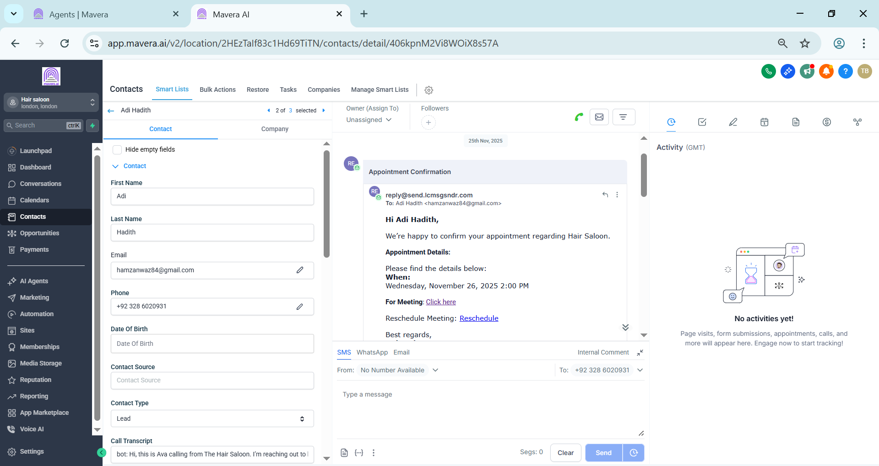

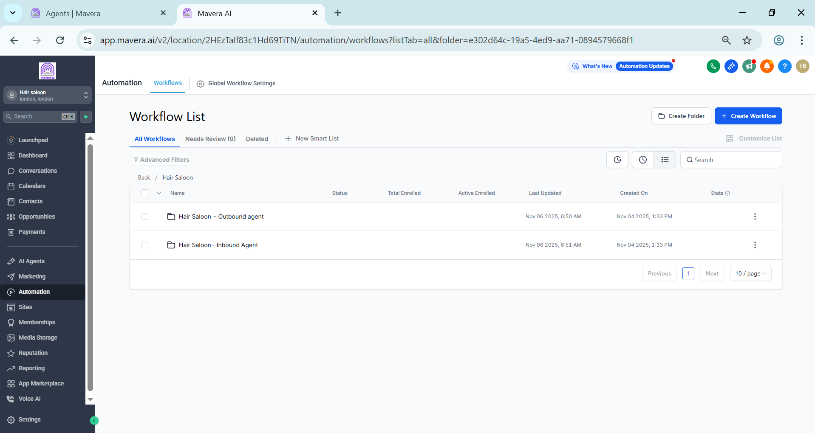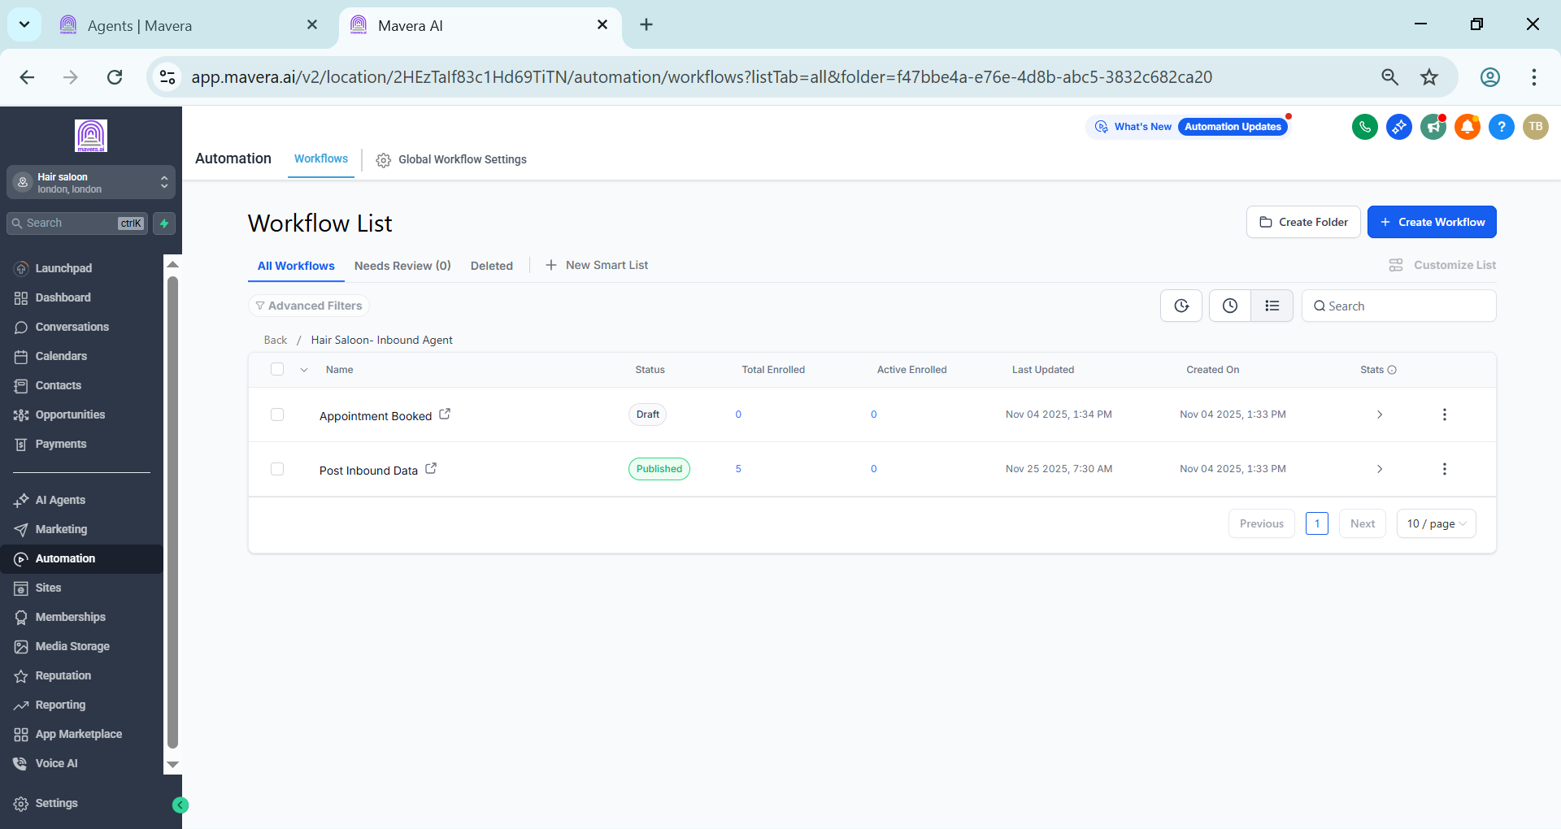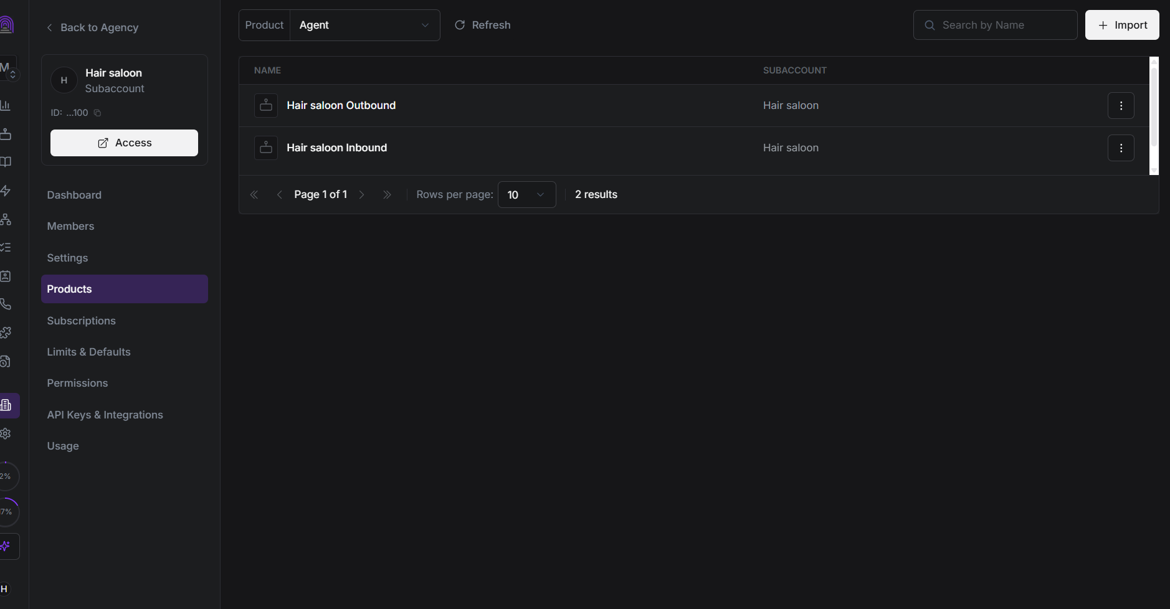

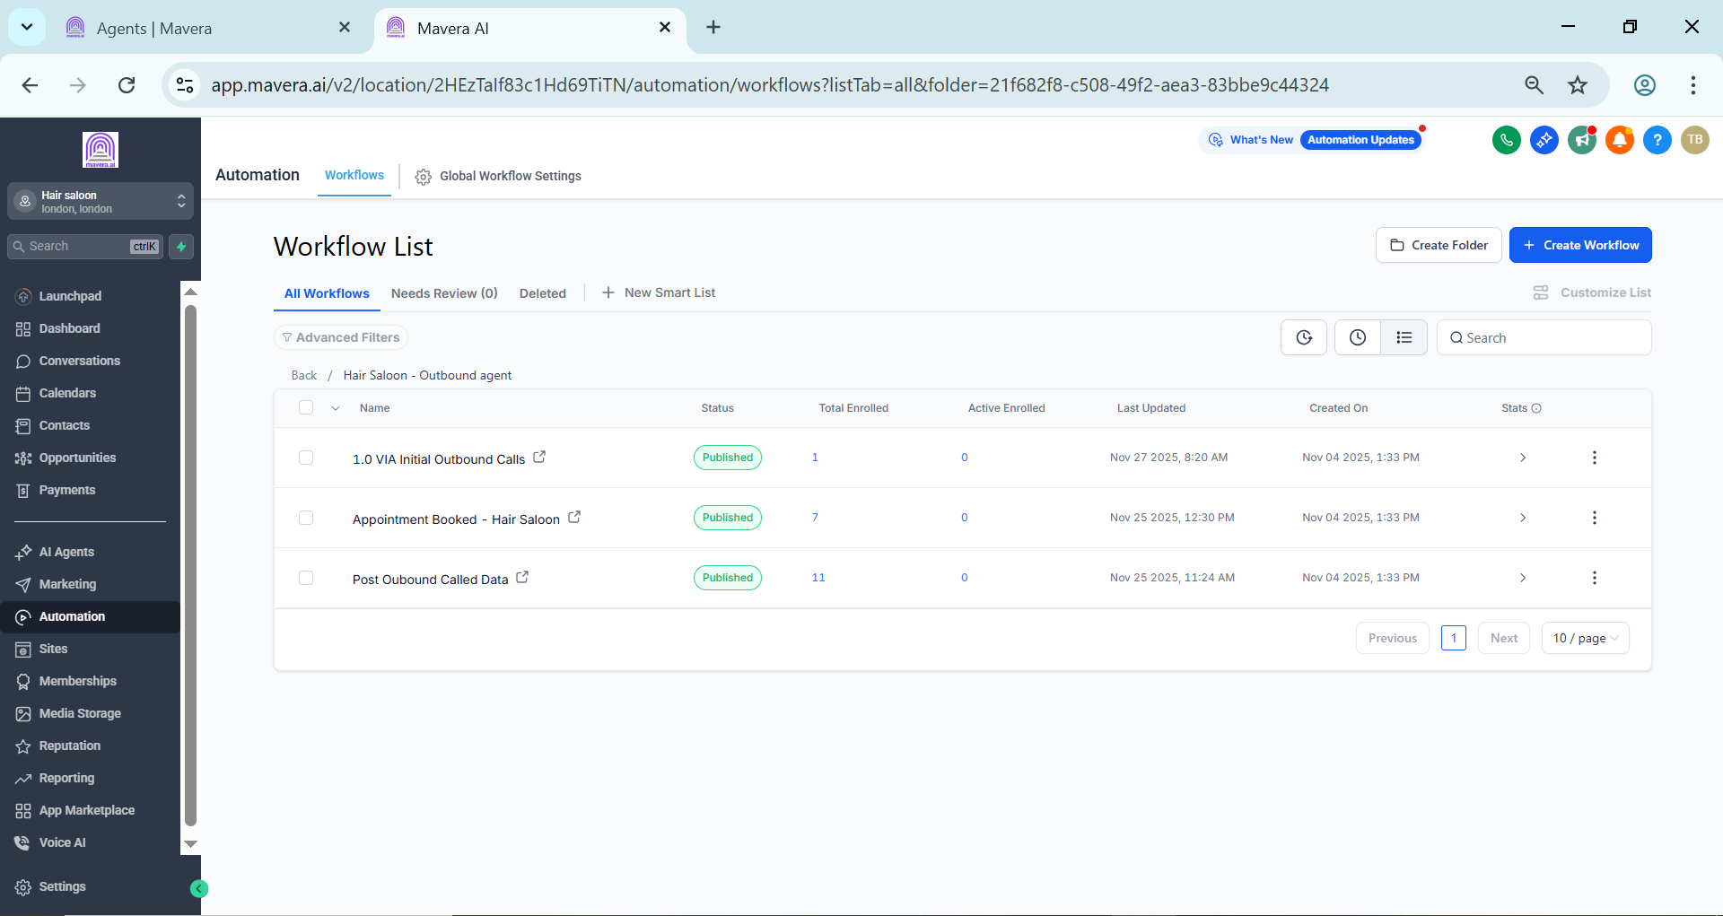

CRM & Subaccount Setup
The salon was configured as a dedicated GoHighLevel subaccount with its own:
• Contacts and CRM
• Voice agents
• Inbound workflows
• Outbound workflows
• Appointment handling
• Email communication

Inbound Automation
The inbound setup handles incoming customer interactions and moves them through the appropriate workflow.
The system includes:
• Inbound agent handling
• Appointment booking
• Post interaction data processing
• Customer record updates

Outbound Automation
The outbound setup manages the lead calling process through separate workflows.
It includes:
• Initial outbound calls
• Appointment booking
• Post call data processing
• Follow up handling
This keeps the calling process structured and allows lead activity to be tracked inside the CRM.

Appointment & Email Automation
Once an appointment is booked, the system handles the related customer communication.
Appointment confirmation emails include:
• Customer name
• Appointment date and time
• Meeting or booking details
• Rescheduling information
The communication is recorded against the customer contact inside GoHighLevel.

Technology
• GoHighLevel
• Voice Agents
• CRM
• Workflow Automation
• Appointment Booking
• Email Automation

Result
A centralized hair salon automation system that connects inbound calls, outbound calls, appointment booking, follow ups, and customer communication inside GoHighLevel.
The setup reduces manual lead handling and gives the salon a structured process for managing customers from the first interaction through appointment confirmation.

